Evaluation Metrics

In regression analysis, we use evaluation metrics to assess the performance of a model. These metrics quantify how well the predicted values align with the actual values. Here's a breakdown of the key metrics used for evaluating regression models.
Common Regression Evaluation Metrics
Mean Absolute Error (MAE)
MAE measures the average magnitude of errors in a set of predictions, without considering their direction. It's simply the average of the absolute differences between the predicted and actual values.
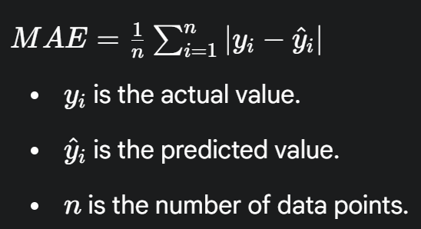
Pros:
- Interpretable: The units of MAE are the same as the target variable, making it easy to understand.
- Robust to outliers: Since it uses absolute differences, it's less affected by extreme values compared to other metrics that use squared differences.
Cons:
- It does not penalize large errors as much as MSE.

Mean Squared Error (MSE)
MSE calculates the average of the squared differences between the predicted and actual values. This metric penalizes larger errors more heavily than smaller ones.
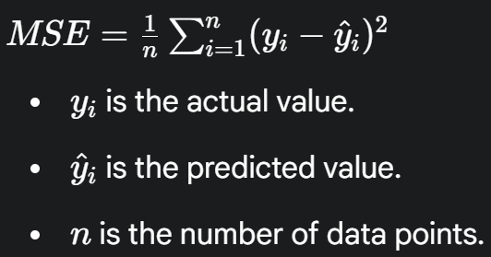
Pros:
- Highly sensitive to large errors: The squaring of errors gives a disproportionately high weight to large errors, which can be useful if large errors are particularly undesirable.
Cons:
- Not easily interpretable: The units of MSE are the square of the target variable's units, which makes it less intuitive to interpret.
- Sensitive to outliers: Because it squares the errors, a single large outlier can significantly increase the MSE.

Root Mean Squared Error (RMSE)
RMSE is the square root of the MSE. It brings the error measure back to the same units as the target variable, making it more interpretable than MSE.
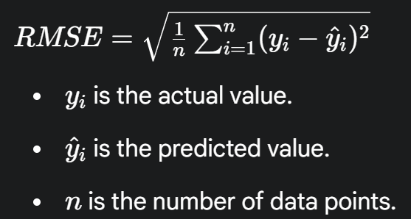
Pros:
- Interpretable: It's in the same units as the target variable, similar to MAE.
- Penalizes large errors: It retains the sensitivity to large errors that MSE has.
Cons:
- Sensitive to outliers: Like MSE, it is significantly affected by outliers.

R-squared (R2)
R2, also known as the coefficient of determination, measures the proportion of the variance in the dependent variable that's predictable from the independent variable(s). It provides an indication of the goodness of fit of a model. A value of 1 indicates a perfect fit, while a value of 0 indicates the model explains none of the variability of the response data around its mean.

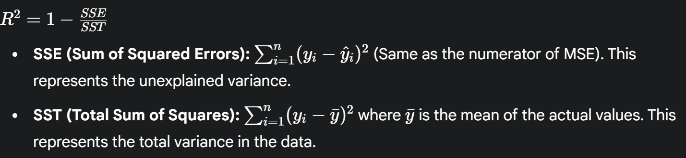
Pros:
- Provides a relative measure of fit: It's a normalized metric that is always between 0 and 1 (or can be negative for very poor models), making it easy to compare different models.
Cons:
- Adding more features can increase R2: It does not account for the number of features in the model. As you add more independent variables, the R2 value will either increase or stay the same, even if the new variables are not useful. This can lead to overfitting.

Adjusted R-squared
Adjusted R2 is a modified version of R2 that accounts for the number of predictors in the model. It increases only if the new predictor improves the model more than would be expected by chance. It is a better metric for comparing models with a different number of predictors.
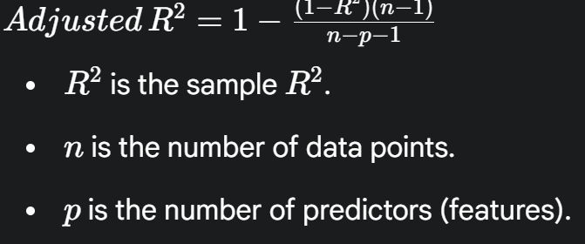
Pros:
- Corrects for overfitting: It penalizes the addition of useless features, making it a more reliable metric for model comparison than standard R2.
Cons:
- It can still be misleading if there are many irrelevant features.

Mean Absolute Percentage Error (MAPE)
MAPE expresses the error as a percentage of the actual value. It's calculated by taking the average of the absolute percentage errors for each data point.
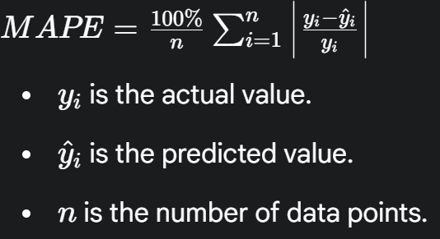
Pros:
- Scale-independent: It's a percentage, so it can be used to compare the performance of models on different scales.
Cons:
- Undefined for zero values: If any of the actual values (yi​) are zero, the denominator becomes zero, making the metric undefined.
- Biased: It can heavily penalize negative errors more than positive errors.

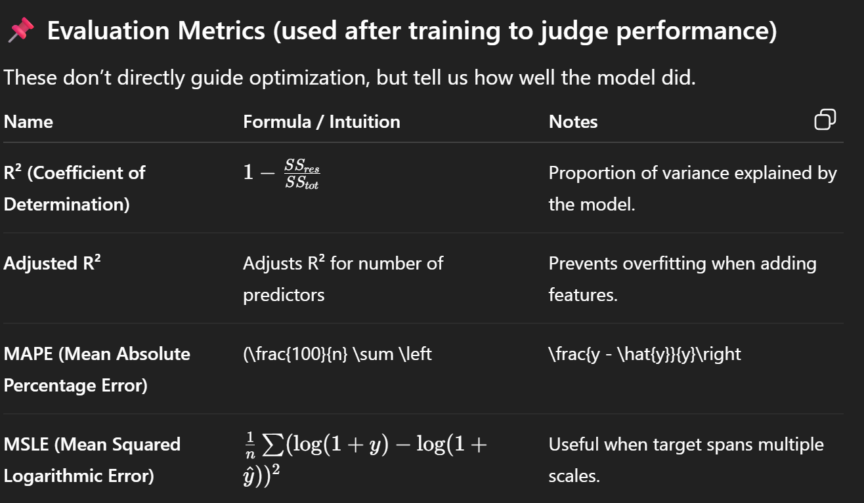
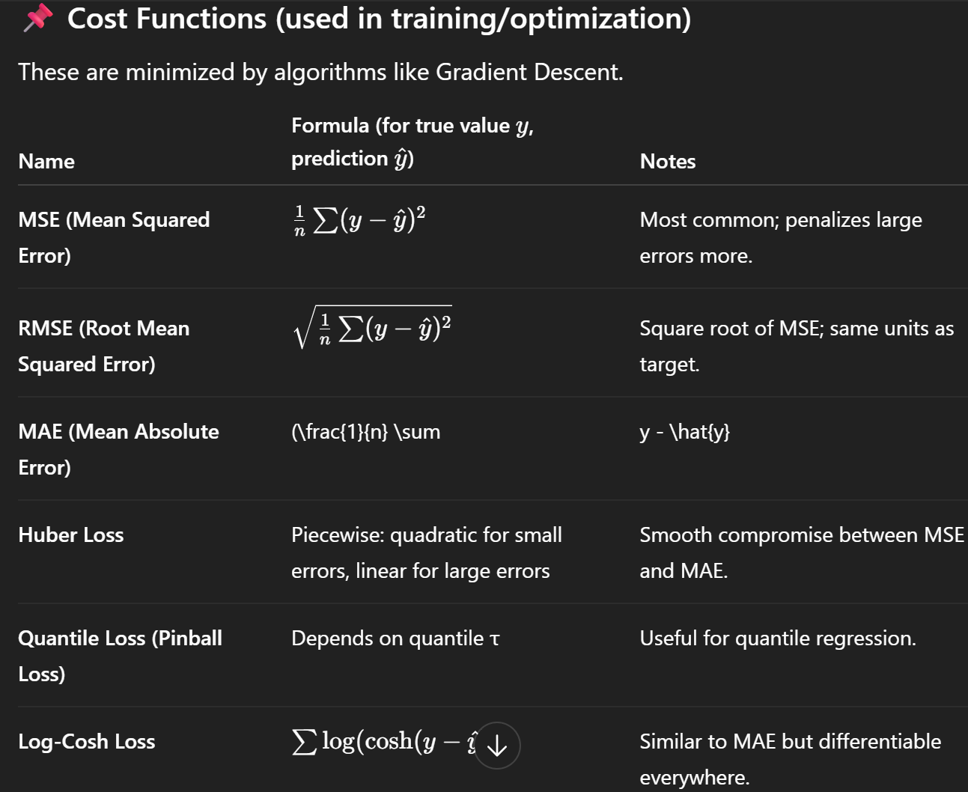

👉 Key Difference:
- Cost Functions = “teacher” during training (guides optimization)
- Evaluation Metrics = “exam” after training (judges performance)

Basically Cost Functions are used during the training of the model whereas Evaluation Metrics are used after the training.

